## horizontal line



MAITENANCE TRACKER MOBILE APPLICATION

28.08.23

**─**

K. GOKULAPPADURAI B.E (CSE)

App development Trainee at Variablez

# Overview

This Mobile application is going to be useful for the young and fast moving world people who are supposed to forget and ignore the importance of maintenance and due dates of Particular things or mandatory real time applications in day to day life.

# Goals

1. To make the people aware of the product maintenance by notifying them and allowing them to save and view the details with the update of that product.
2. To monitor and control the quality with increasing life span of the product with the correct maintenance and updating the damaged or dead conditioned attachments of the product.

# Specification

1. Our Application will consist of only two main categories one is HOME APPLIANCE another one is TRANSPORTS AND VEHICLES.
2. There will be a heading as Category in the home page when we open the application. Which will consist of only two criteria as per the number of categories.
3. The Category page has the n number of products in it with the name.
4. There will be an add button on each category page to add a product with all the details needed to the product with due date, insurance etc.,
5. There will be also a delete and edit button on every item of the category
6. In the main page there will be a drawer which has the account and user details with the upcoming due date of the production in sorted order.
7. In the backend there integrated with a sql database for the application data update and to maintain the due date details too in it.

# 

1. **SOFTWARE REQUIREMENT SPECIFICATIONS (SRS):**

1. Introduction

1.1 Purpose

The purpose of this Mobile Application is to help users, particularly those with busy lifestyles, remember and manage maintenance tasks and due dates for various products, including home appliances and vehicles.

1.2 Scope

The application will primarily focus on two main categories: Home Appliances and Transports and Vehicles. Users can add, view, edit, and delete products within these categories. The application will provide notifications and reminders for maintenance and due dates.

2. Functional Requirements

2.1 User Registration and Authentication

- Users can create accounts and log in.

- User authentication is required to access and use the application.

2.2 Categories and Products

- The application will have two main categories: "Home Appliance" and "Transports and Vehicles."

- Users can add products to these categories with the following details:

- Product name

- Description

- Due date for maintenance

- Insurance information (if applicable)

- Other relevant details

2.3 Viewing and Managing Products

- Users can view a list of products within each category.

- Each product entry will have options to edit or delete the product.

- Products will be sorted by their upcoming due dates.

2.4 Notifications and Reminders

- The application will send notifications and reminders to users for upcoming maintenance tasks and due dates.

- Users can customize notification preferences.

3. Non-Functional Requirements

3.1 Performance

- The application should perform efficiently, even with a large number of users and products.

3.2 Security

- User data should be securely stored and transmitted.

- Proper authentication and authorization mechanisms will be implemented.

3.3 Database

- The application will be integrated with an SQL database to store user account information, product details, and due date information.

3.4 User Interface

- The user interface should be intuitive and user-friendly, with easy navigation.

4. Constraints and Assumptions

- The application development will assume a reasonable budget and timeline.

- The SQL database will be maintained and backed up regularly.

- The application will initially be developed for mobile platforms (iOS and Android).

5. Testing and Quality Assurance

- Comprehensive testing will be performed to ensure that all features work as intended.

- User acceptance testing will involve real users to verify that the application meets their needs.

6. Documentation

- User manuals and technical documentation will be provided to assist users and developers.

7. Timeline and Milestone.

1. **EXISTING SYSTEM REVIEW AND FEEDBACKS:**

There are two application existing for the industrial purpose and the vehicle purpose of maintenance and we are supposed to integrate them both and our target customers are not an domain oriented person, just we are going to build and allow the home old and simple users only to the simplicity is required more and no complex gui’s these application have the mess of more details and n numbers of input fields too we are supposed to decrease them all.

1. Maintenance Management OxMaint:

Maintenance management software. Connect all your field staff and maintenance teams in real time. Report, track and coordinate repairs. Awesome for asset, equipment & vehicle repair management. [**LINK TO APP**](https://play.google.com/store/apps/details?id=com.jrs.oxmaint&hl=en&gl=US).

**Feedback:** To decrease the details and the input field according to our application with the mandatory details only and also to lessen the users burden to add a item in the application.

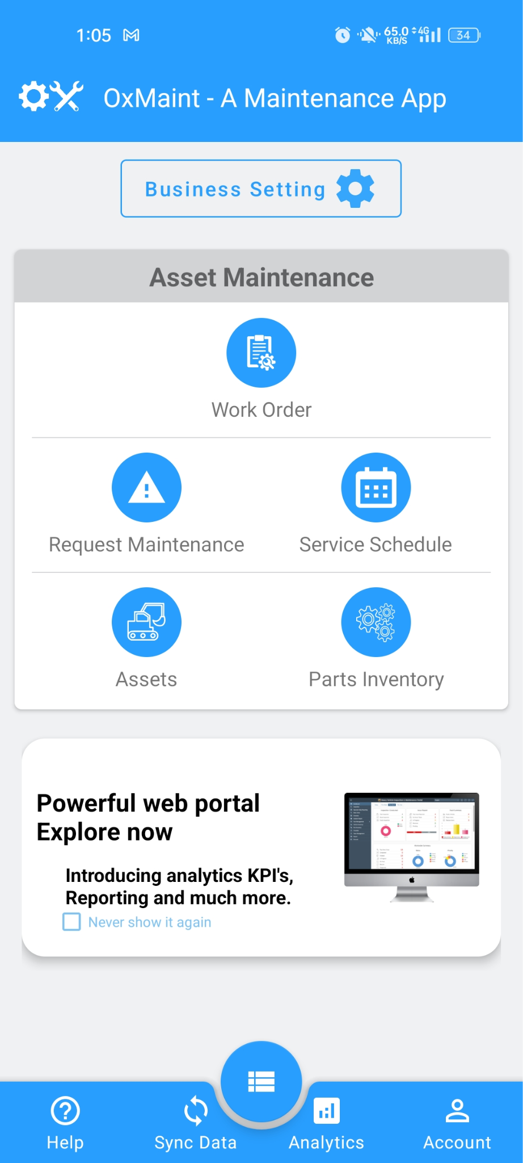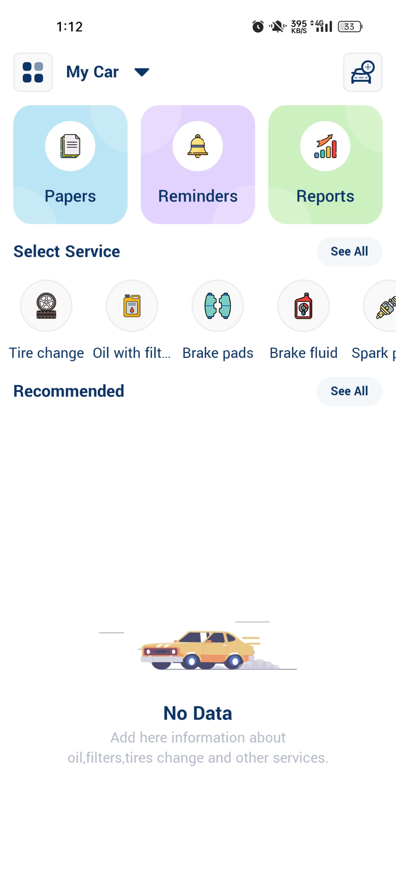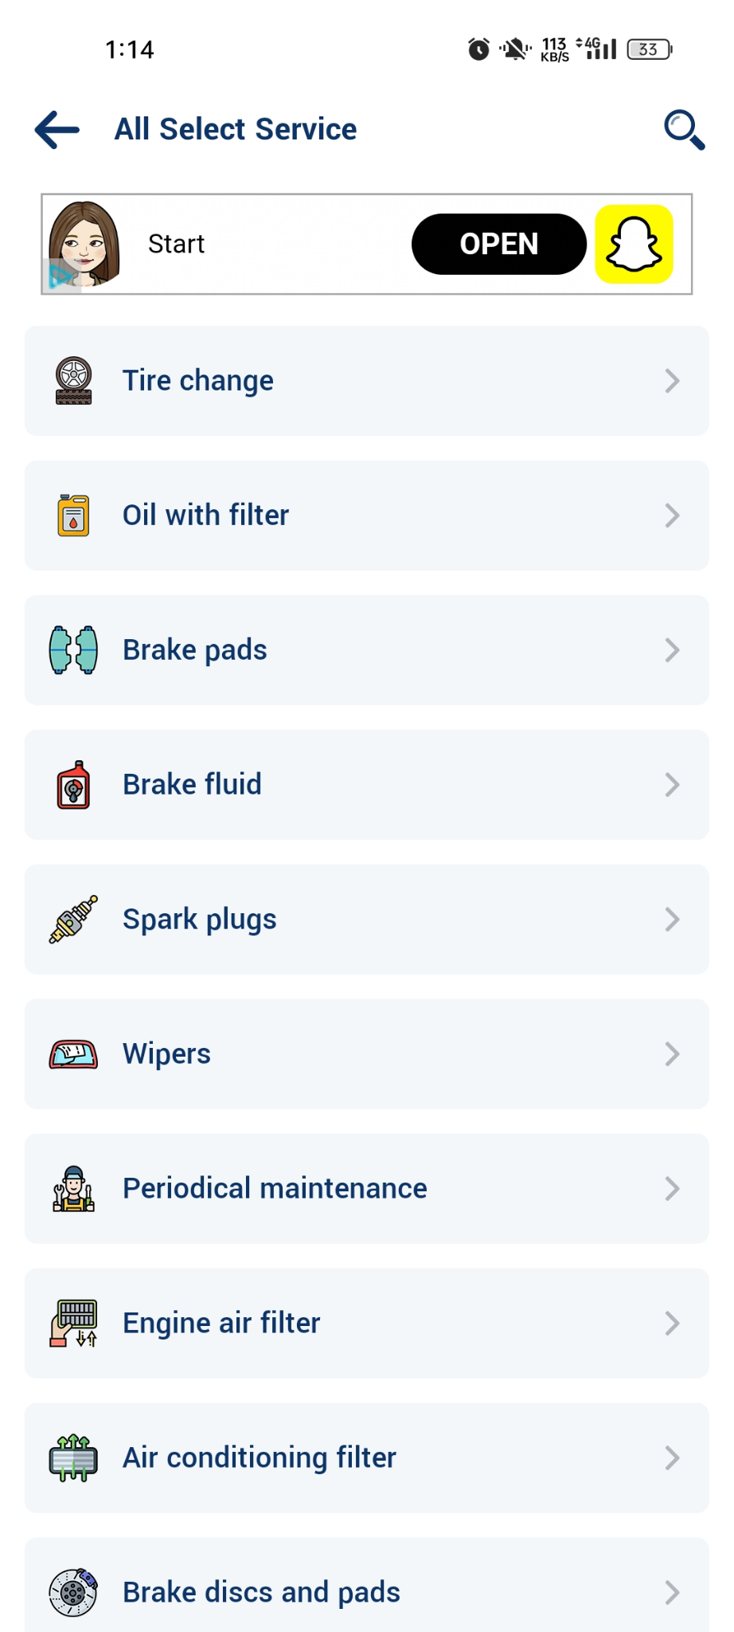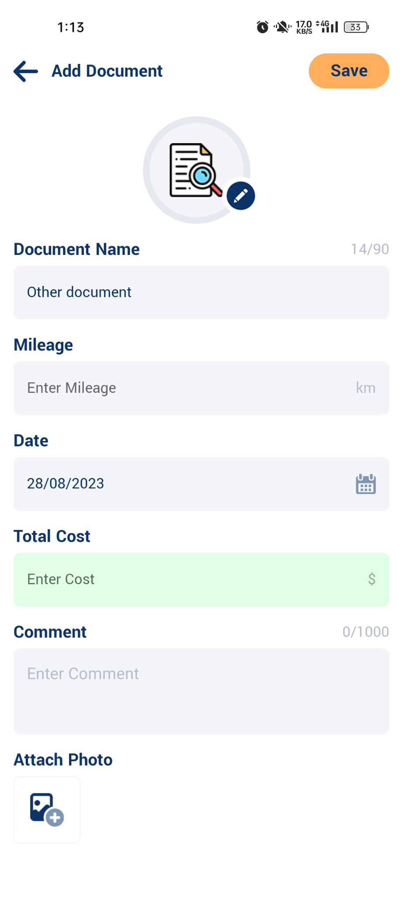

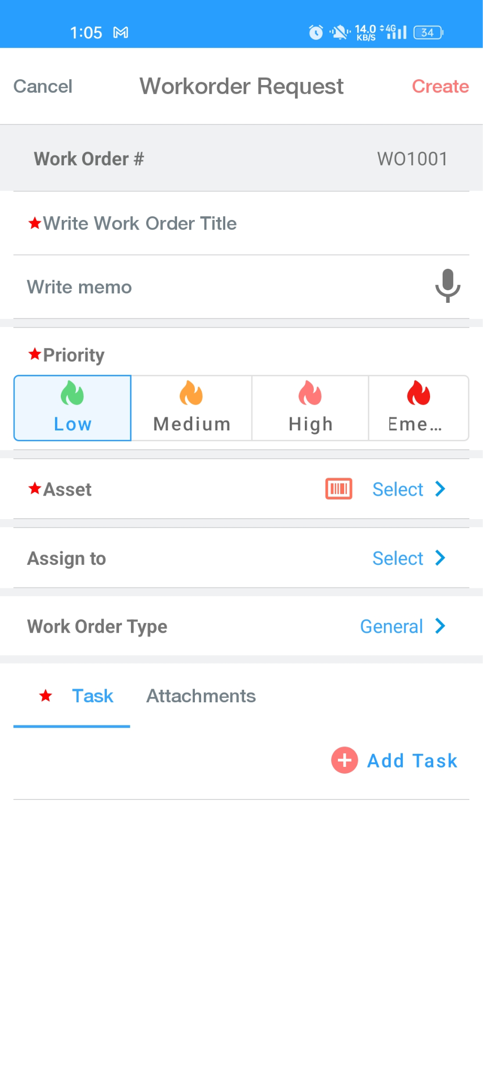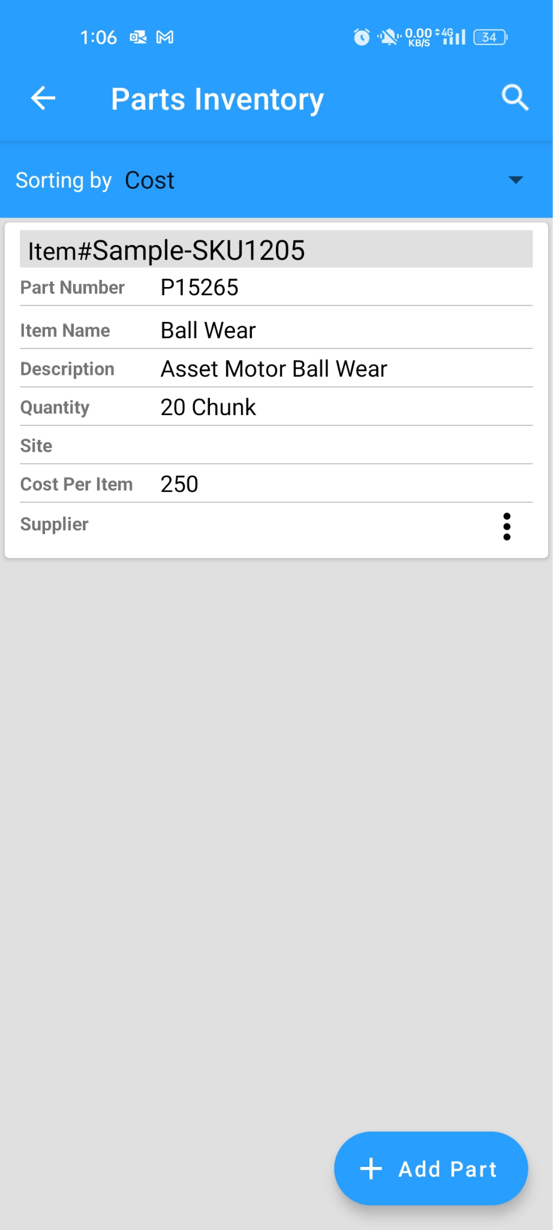

1. Vehicle Maintenance Tracker:

For your car, motorcycle, bus or truck, for personal use or for professional drivers to add car repairs, insurances, fines and other expenses. You may separately specify spare parts and labor cost. Attach photos to your car maintenance log. This is complete car management tool that helps you track your vehicle’s data for multiple vehicles and services. It is a simple yet effective logbook for your car and see reports of expenses. [**LINK TO APP**](https://play.google.com/store/apps/details?id=com.technoapps.carservicetracker&hl=en&gl=US).

**Feedback:** In this application we are supposed to minimize the service and add only mandatory service for the custom vehicle which to user adds and it depend up to vehicle too, we are supposed to add the insurance and policy detail for that application also.

1. **DEVELOPMENT:** TO BE CONTINUED…….
2. **SYSTEM DESIGN:** TO BE CONTINUED…….
3. **TESTING:** TO BE CONTINUED…….
4. **BACKEND INTEGRATION:** TO BE CONTINUED…….
5. **MAINTENANCE :**TO BE CONTINUED…….